Annex #1

Algorithm ALG1

Operators Mutations (Swap+Insert)

Studying Probability of Mutation – Each line represents the median of 3 executions. The number of items for this entry is 500 and the optimal solution is 216.

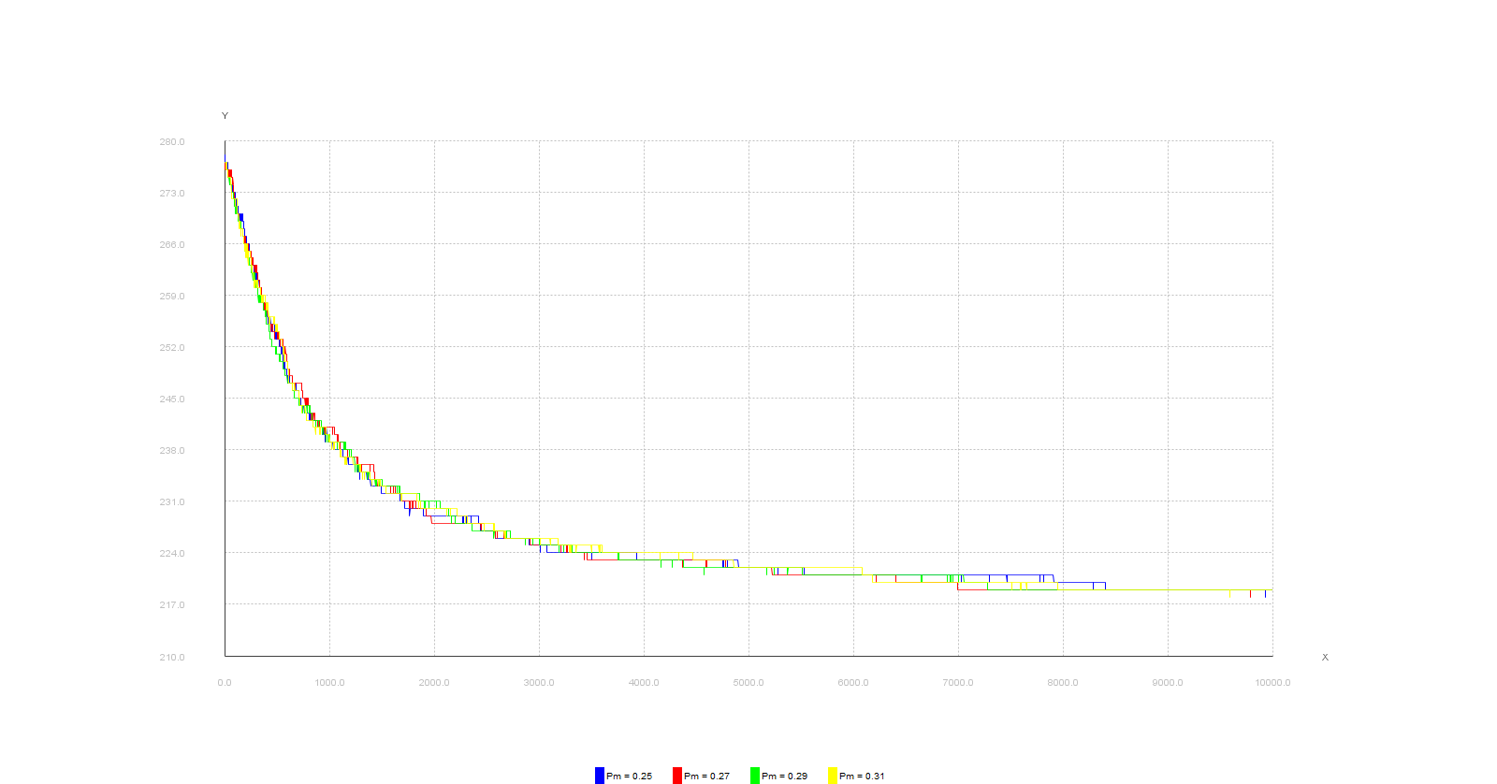

Annex #2

Algorithm ALG2

Operators Mutations (Swap+Insert)

ALG2 using 0.27 as Mutation Probability. Each line represents the median of 3 executions. The number of items for this entry is 500 and the optimal solution is 216.

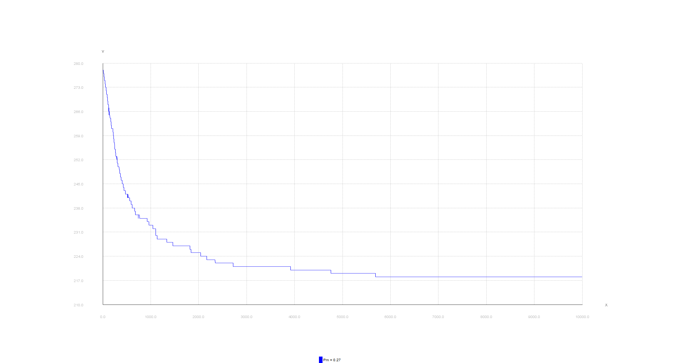

Annex #3

Algorithm ALG2

Operators Mutations (Swap+Insert)

Changing the number of Individuals ALG2 using 0.27 as Mutation Probability. Each line represents the median of 3 executions. The number of items for this entry is 200 and the optimal solution is 99.

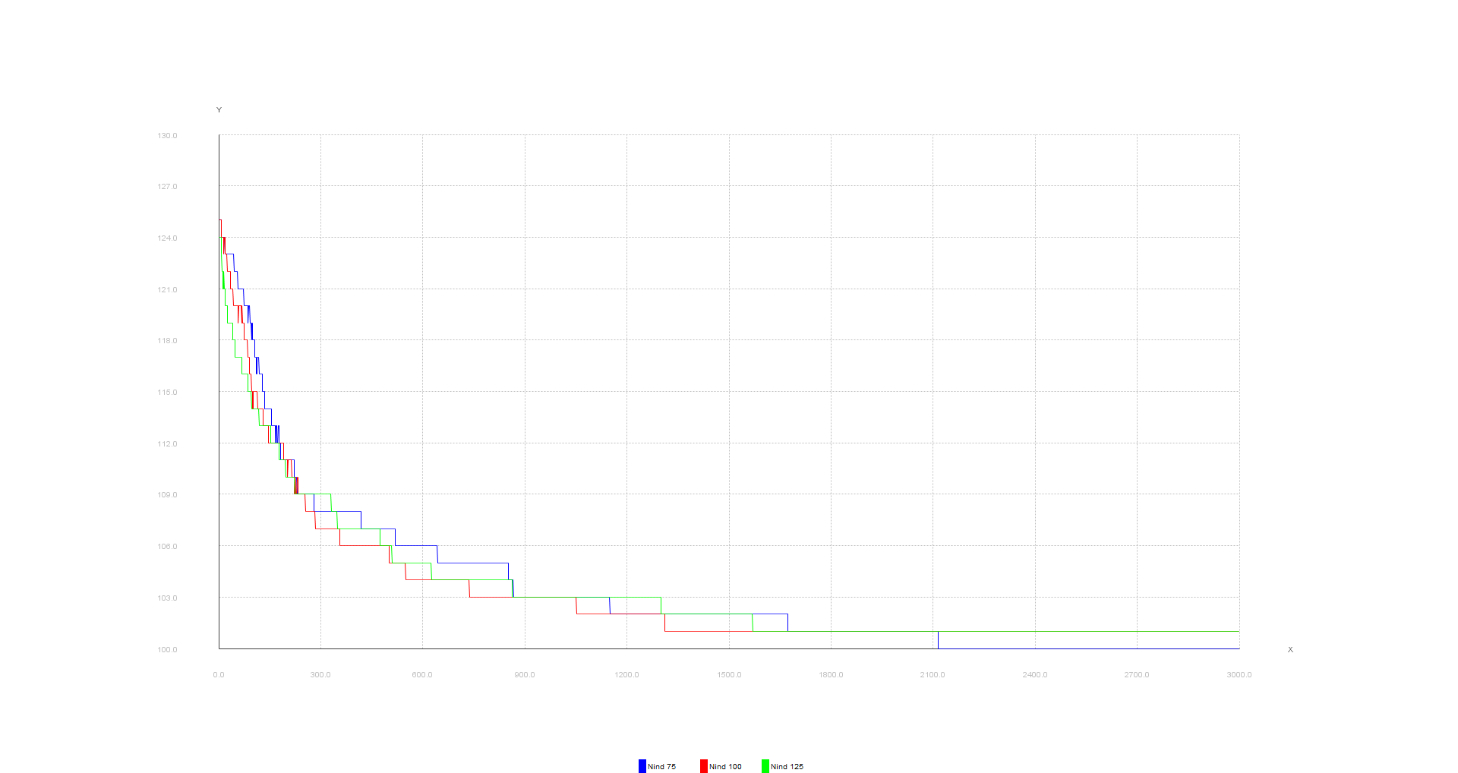

Annex #4

Algorithm ALG1

Operators Mutations (Swap+Insert) + Recombination without best assignment

Changing the probability of mutation. Results obtained using ALG2. Each line represents the median of 3 executions. The number of items for this entry is 100 and the optimal solution is 99. Probability of recombination was 0.25%

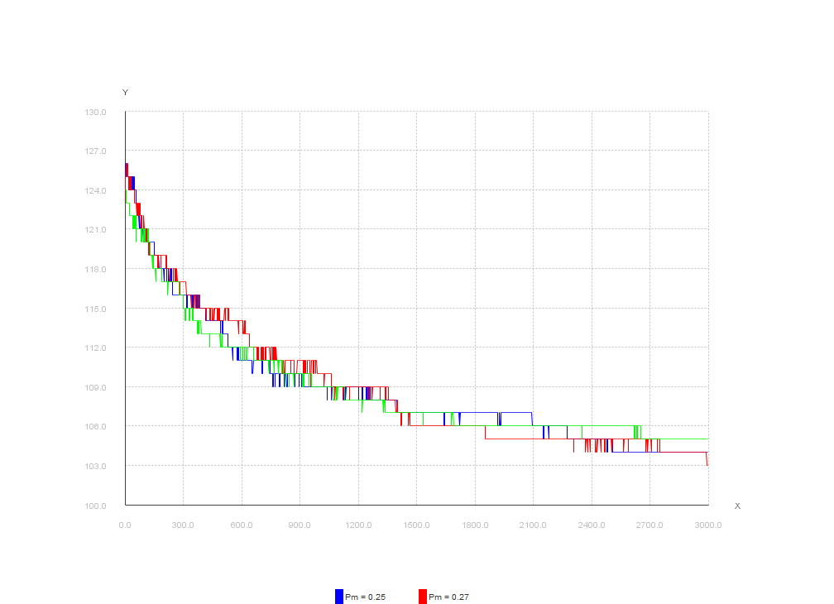

Annex #5

Algorithm ALG1

Operators Mutations (Swap+Insert) + Recombination without best assignment

Studying the recombination probability. Results obtained using ALG1. Each line represents the median of 3 executions. The number of items for this entry is 200 and the optimal solution is 99.

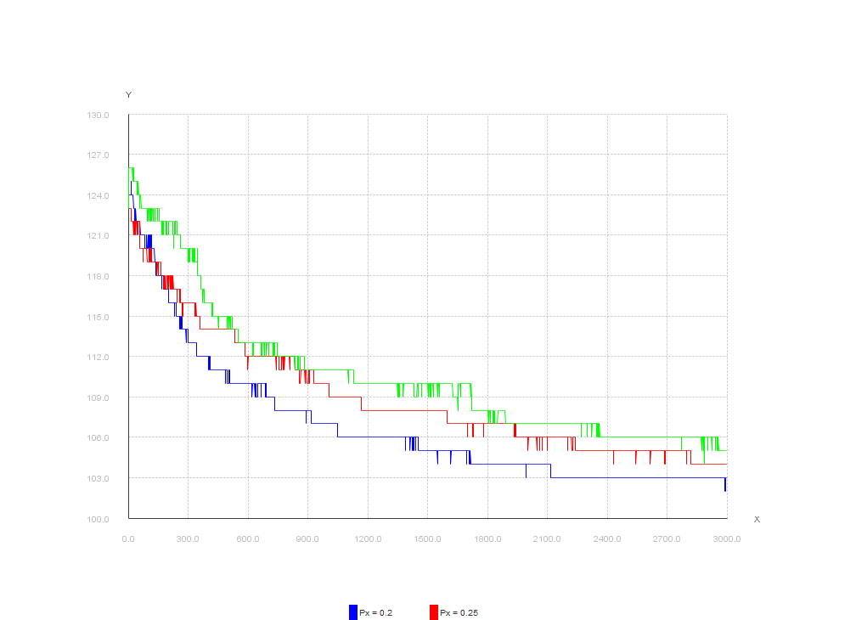

Annex #6

Algorithm ALG2

Comparison of implementations. Results obtained using ALG2. Each line represents the median of 3 executions. The number of items for this entry is 200 and the optimal solution is 99. In blue color we have only mutation, in red we have recombination without best assignment and at green we have recombination with best assignment.

